# Instructions

The marketing team has requested that you create a directory structure and some placeholder files for their intranet project application on the Windows server you created for them previously. Please create the following directories:

C:\intranet

C:\intranet\content

C:\intranet\content\images

C:\intranet\shared

Also, please create a file called index.html within the website directory and enter the following text:

<h1>Future Home of ACME Intranet</h1>

<img src=”./images/underconstruction.jpg”>

Finally, search the internet for a jpeg (image) depicting “under construction”. Download the file to the server. Move this file to the images directory and rename it to underconstruction.jpg.

Test the file by opening it with Internet Explorer.

# Screenshots

Paste the required screen shots under each description.

1. Show the directories C:\intranet and C:\intranet\content in Windows File Explorer

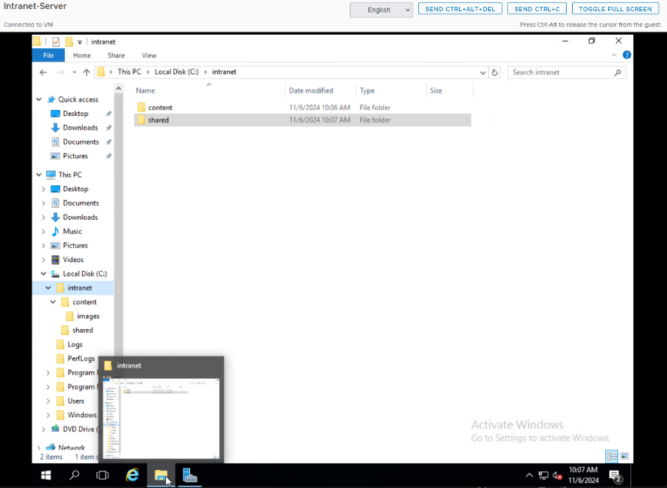

1. Open the index.html file with notepad and show the text in the file

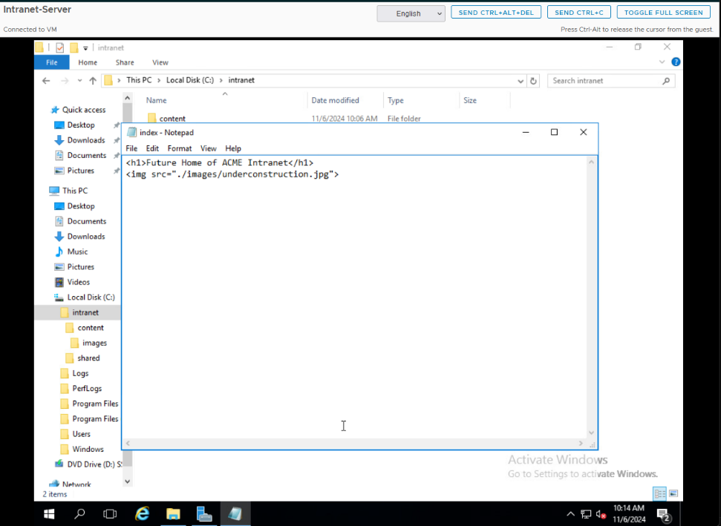

1. Take a screen shot showing the index.html file opened in Internet Explorer

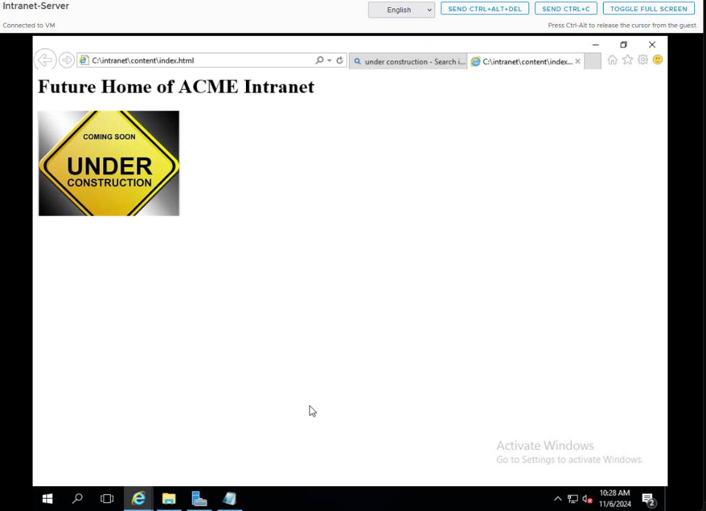

# Documentation

Record and explain all the steps you took to complete the task. Include any commands used, screen shots showing GUI interfaces, or any other information that would help you recreate the task.

**Note: You will be allowed to use this documentation to help you complete future assignments.**

Opened File Explorer and navigated to C:\.

Created a new folder named intranet in C:\.

Opened the intranet folder and created a new folder named content.

Opened the content folder and created a new folder named images.

Returned to the intranet folder and created a new folder named shared.

Took a screenshot showing the C:\intranet and C:\intranet\content directories in Windows File Explorer.

Opened Notepad.

Entered the following HTML code:

<h1>Future Home of ACME Intranet</h1>

<img src="./images/underconstruction.jpg">

Saved the file as index.html in the C:\intranet directory, ensuring Save as type was set to All Files.

Verified the file content by reopening index.html in Notepad.

Took a screenshot showing the content of index.html in Notepad.

Opened a web browser and searched for a JPEG image with “under construction”.

Downloaded the selected image to the server.

Moved the downloaded image to the C:\intranet\content\images directory and renamed it to underconstruction.jpg

Opened Internet Explorer from the Start Menu.

Entered C:\intranet\index.html in the Internet Explorer address bar to open the file.

Verified that the page displayed the header “Future Home of ACME Intranet” and the “under construction” image.

Took a screenshot showing index.html opened in Internet Explorer.